

Mortality Tables for Uganda Assured Lives from 2015 to 2019

World Bank

Contents
Executive Summary 1
1. Introduction 3
2. The Data 4
3. Mortality Experience between Uganda, Kenya and Rwanda 11
4. Development of Mortality Table for Uganda 21
5. Graduation Results 24
6. Comparison of Uganda Assured Lives Table 27
7. Summary and Recommendations 34
ANNEXURE 1 35
MALE - RAW AND GRADUATED RATES 35
ANNEXURE 2 38
FEMALE - RAW AND GRADUATED RATES 38
ANNEXURE 3 41
KE 2007-2010 Mortality Tables for Assured Lives in Kenya 41
Rwanda Mortality Table 2012 - 2016 42
ANNEXURE 4 43
Individual Life In-Force 43
Individual Life Claims 44
Group Life In-Force 44
Group Life Claims 45

Executive Summary

- The purpose of the project is to construct a new Uganda Assured Lives Mortality Table for pricing and reserving of life insurance products.

- The construction of the new mortality table was based on the cleaned data from the major 3 companies in Uganda. The study was carried out separately for Male and Female, including all products and all lives under the Individual Business during the five years ending 31 December 2019. The summary of data considered in this study is as follows:

Table EX.1 The summary of data with curtate duration greater or equal to 0 years
 | Total Exposure 0+ | Total Death 0+
Male | 99,344 | 86
Female | 68,006 | 47

The data from Group Business has not been considered in the study due to lack of gender and age information in the group data.

- Crude rates are derived based on the number of deaths and exposure in each age. Graduation methods as described in Section 4 are considered based on the distribution of the crude rates and made reference to KE 2007-2010 Mortality Tables for Assured Lives in Kenya.

- Two graduation methods are used in order to come out with the graduated rates namely Brass Logit and Coale Kisker method:

- Brass Logit method is used by making reference to the KE 2007-2010 Mortality Tables for Assured Lives in Kenya. Adjustments have been made to reflect the difference in population mortality rates between Uganda and Kenya.

- Coale Kisker method is used instead of common exponential method as it can produce a smoother closure of a life table at older ages. The start age for Coale Kisker method is set at age 60 for Male, and age 50 for Female, with the target age of 115.

- The graduated mortality rates with age nearest birthday definition are as below. The details of the graduation are set out in Section 4 and 5 of this report.

GRADUATED RATES
AGE  NEAREST | MALE | FEMALE | AGE  NEAREST | MALE | FEMALE | AGE  NEAREST | MALE | FEMALE
20 | 0.001563 | 0.002015 | 47 | 0.004330 | 0.002840 | 74 | 0.059351 | 0.048667
21 | 0.001822 | 0.002103 | 48 | 0.004475 | 0.003021 | 75 | 0.066164 | 0.053633
22 | 0.002053 | 0.002174 | 49 | 0.004613 | 0.003213 | 76 | 0.073612 | 0.059042
23 | 0.002251 | 0.002227 | 50 | 0.004746 | 0.003417 | 77 | 0.081736 | 0.064925
24 | 0.002405 | 0.002260 | 51 | 0.004877 | 0.003861 | 78 | 0.090577 | 0.071318
25 | 0.002508 | 0.002272 | 52 | 0.005006 | 0.004362 | 79 | 0.100174 | 0.078255
26 | 0.002554 | 0.002259 | 53 | 0.005135 | 0.004924 | 80 | 0.110567 | 0.085773
27 | 0.002554 | 0.002228 | 54 | 0.005264 | 0.005551 | 81 | 0.121797 | 0.093912
28 | 0.002520 | 0.002180 | 55 | 0.005394 | 0.006252 | 82 | 0.133901 | 0.102712
29 | 0.002461 | 0.002123 | 56 | 0.006056 | 0.007033 | 83 | 0.146915 | 0.112215
30 | 0.002393 | 0.002060 | 57 | 0.006958 | 0.007903 | 84 | 0.160874 | 0.122464
31 | 0.002325 | 0.001995 | 58 | 0.007991 | 0.008872 | 85 | 0.175809 | 0.133504
32 | 0.002270 | 0.001936 | 59 | 0.009178 | 0.009948 | 86 | 0.191748 | 0.145382
33 | 0.002239 | 0.001888 | 60 | 0.010542 | 0.011143 | 87 | 0.208717 | 0.158144
34 | 0.002246 | 0.001857 | 61 | 0.012059 | 0.012468 | 88 | 0.226737 | 0.171841
35 | 0.002297 | 0.001847 | 62 | 0.013796 | 0.013936 | 89 | 0.245823 | 0.186521
36 | 0.002390 | 0.001858 | 63 | 0.015751 | 0.015559 | 90 | 0.265986 | 0.202236
37 | 0.002518 | 0.001888 | 64 | 0.017947 | 0.017352 | 91 | 0.287231 | 0.219038
38 | 0.002674 | 0.001932 | 65 | 0.020409 | 0.019331 | 92 | 0.309556 | 0.236978
39 | 0.002855 | 0.001988 | 66 | 0.023163 | 0.021513 | 93 | 0.332954 | 0.256109
40 | 0.003049 | 0.002052 | 67 | 0.026236 | 0.023915 | 94 | 0.357409 | 0.276485
41 | 0.003253 | 0.002121 | 68 | 0.029657 | 0.026556 | 95 | 0.382898 | 0.298158
42 | 0.003458 | 0.002194 | 69 | 0.033459 | 0.029457 | 96 | 0.409390 | 0.321182
43 | 0.003656 | 0.002266 | 70 | 0.037672 | 0.032639 | 97 | 0.436845 | 0.345608
44 | 0.003843 | 0.002336 | 71 | 0.042332 | 0.036126 | 98 | 0.465214 | 0.371490
45 | 0.004015 | 0.002512 | 72 | 0.047474 | 0.039942 | 99 | 0.494442 | 0.398876
46 | 0.004177 | 0.002671 | 73 | 0.053134 | 0.044113 | 100 | 0.524462 | 0.427817

Introduction

In 2019, the total population of Uganda was 44 million, which 46.5% were below age 15, 51.54% were aged 15 to 64 years and 1.96% were 65 years old and older. The median age of the population in Uganda is 15.9 years, this made Uganda as one of the world’s youngest countries in the world. Based on the data collected in World Bank 2019, 49.26% of the population is Male in 2019.* The life expectancy at birth for male is 60.2 and for female is 64.8.**

The insurance industry is relatively young and the lack of country specific mortality tables has further hampered the product pricing and statutory valuation. The Insurance Regulatory Authority of Uganda (“IRA”) has requested technical assistance to develop mortality tables for Uganda that can be applied to both mortality and longevity products.

All life insurance companies operating in Uganda have been requested to submit data from 2018 to 2019 with respect to the number of in-force policies as at the end of each calendar year as well as the number of deaths during each calendar year. The initial data was provided by IRA. The list of life insurance companies which have submitted the initial data are:

- CIC Africa Life Assurance
- ICEA Life Assurance
- Jubilee Insurance Company of Uganda Limited
- Liberty Life Assurance Uganda
- Prudential Assurance Uganda Limited
- Sanlam Uganda Life Insurance
- UAP Life Assurance Uganda

Based on the initial data provided by IRA, we found that the data for year 2018 and 2019 are not sufficient to develop mortality tables for this project. We have further carried out a survey to understand the availability of data in the life insurance industry. Based on the results of the survey, we have narrowed down to 3 largest companies and have collected further data from these companies. The data from these 3 largest companies are then used to represent the mortality experience for Uganda Assured Lives.

* Data from World Bank, World Development Indicators

** Data from World Health Organisation, Global Health Observatory data repository

The Data

Analysis of Data

- IRA has provided initial set of data (“Initial Data”) from all life insurance companies in Uganda. The initial data received are for year 2018 and 2019 only. The table below shows the analysis of Initial Data:

Table 2.1: Summary of Initial Data received from IRA.
Companies | Inforce | Death | Gender | Date of Birth
1. CIC Africa Life
Individual | 1,533 | 5 | ✔ | ✔
Group | 2,388 | 735 | Missing | Missing
2. ICEA Life
Individual | 10,509 | No information | ✔ | ✔
Annuity | 4 | No information | ✔ | ✔
Group Credit | 93,669 | 15 | Missing | Missing
Group Life | 73,225 | 8 | Missing | Missing
3. Jubilee Uganda
Individual | 41,502 | 22 | ✔ | ✔
Group Life | 416,397 | 798 | Missing | Missing
4. Prudential
Individual | 26,319 | 17 | ✔ | ✔
Group | No information | 21 | Missing | Missing
5. Sanlam
Individual | 21,458 | 7 | ✔ | ✔
Group | No information | No information | ✔ | ✔
6. UAP Life
Individual | 52,435 | No information | ✔ | ✔
Group | 5,455 | No information | Missing | Missing
7. Liberty Life
Individual | 3,712 | No information | ✔ | ✔
Group | 21,134 | No information | ✔ | ✔
Total Individual | 153,760 | 51
Total Group | 591,134 | 1,577

- There are some challenges in the Initial Data. For example:

    - Data quality varies by contributor, administrative system, and other factors.

    - Not all companies are able to provide us the detail records as at the required date. For example, some contributors provided inforce data for year 2018 only for policies that are still remained inforce as at 31 December 2019. Hence not all exposure can be calculated correctly for each period.

    - Some contributors provided data for only certain blocks of business or certain study years.
    - Some contributors may not be able to supply crucial data field for the mortality study, for example gender and age, for significant part of their business.

- Based on the Initial Data provided by IRA, we found that the amount of data available is far below the acceptable threshold required for a proper mortality study. We have further carried out a survey to understand the available data in the country. The information requested in the survey are:

    - The number of in-force policies as at the end of each calendar year as well as the number of deaths during each calendar year for the past 10 years (2010- 2019)

    - The proportion of assured lives under different medical underwriting:
      - Medical lives: policyholders who have done medical examination at the point of entry.
      - Non-medical lives: policyholders who have not done medical examination at the point of entry but satisfactory evidence of health has been received.
      - Non-underwritten lives: policies sold without any underwriting.

    - The proportion of standard lives and sub-standard lives as at the end of each calendar year.

    - The proportion of business by plan types.

- The summary of the data received from the survey results (“Survey Data”) is shown in the table below.
Table 2.2: Summary of Survey Data for Individual business
Companies |  | 2010 | 2011 | 2012 | 2013 | 2014 | 2015 | 2016 | 2017 | 2018 | 2019 | Total
1. CIC Africa Life | Inforce @ EOY |  |  |  |  |  |  | 186 | 362 | 550 | 1,234 | 2,332
1. CIC Africa Life | Death Claims |  |  |  |  |  |  | 0 | 0 | 2 | 5 | 7
2. ICEA Life | Inforce @ EOY | 62 | 826 | 1,752 | 2,127 | 1,323 | 5,414 | 3,336 | 5,029 | 10,607 | 12,873 | 31,845
2. ICEA Life | Death Claims | 0 | 0 | 2 | 2 | 1 | 2 | 10 | 5 | 11 | 9 | 35
3. Jubilee Uganda | Inforce @ EOY | 420 | 1,347 | 2,717 | 4,014 | 4,851 | 7,306 | 7,976 | 9,488 | 13,264 | 18,750 | 49,478
3. Jubilee Uganda | Death Claims | 0 | 1 | 1 | 3 | 4 | 7 | 8 | 9 | 7 | 18 | 42
4. Prudential | Inforce @ EOY | 0 | 0 | 58 | 101 | 124 | 354 | 2,173 | 5,884 | 9,384 | 17,969 | 35,410
4. Prudential | Death Claims | 0 | 0 | 0 | 0 | 0 | 0 | 1 | 1 | 10 | 5 | 17
5. Sanlam | Inforce @ EOY |  |  | 0 | 5,063 | 8,495 | 18,972 | 27,313 | 27,282 | 20,141 | 21,458 | 96,194
5. Sanlam | Death Claims |  |  | 1 | 0 | 1 | 3 | 5 | 13 | 62 | 159 | 239
6. UAP Life | Inforce @ EOY |  |  |  | 1,894 | 2,972 | 4,219 | 6,773 | 7,581 | 8,586 | 8,215 | 31,155
6. UAP Life | Death Claims |  |  |  | 2 | 5 | 1 | 5 | 7 | 10 | 3 | 25
7. Liberty Life | Inforce @ EOY |  |  |  |  |  |  |  | 1,682 | 1,044 | 986 | 3,712
7. Liberty Life | Death Claims |  |  |  |  |  |  |  | No information
Table 2.3: Summary of Survey Data for Group business
Companies |  |  | 2010 | 2011 | 2012 | 2013 | 2014 | 2015 | 2016 | 2017 | 2018 | 2019 | Total
1. Jubilee Uganda | Inforce @ EOY |  | 5,383 | 5,101 | 4,793 | 7,192 | 12,341 | 16,288 | 19,434 | 45,690 | 44,071 | 48,706 | 208,999
1. Jubilee Uganda | Death Claims |  | 15 | 8 | 27 | 22 | 22 | 20 | 77 | 94 | 140 | 157 | 582
2. Prudential | Inforce @ EOY |  |  |  | 1,179 | 3,008 | 3,841 | 4,122 | 5,315 | 8,026 | 19,590 | 25,721 | 70,802
2. Prudential | Death Claims |  |  |  | 1 | 1 | 8 | 8 | 6 | 2 | 8 | 19 | 53
3. Sanlam | Inforce @ EOY |  |  | 4,883 | 3,013 | 3,949 | 2,182 | 70,432 | 95,117 | 79,442 | 87,778 | 75,519 | 422,315
3. Sanlam | Death Claims |  |  | 16 | 17 | 15 | 43 | 90 | 108 | 192 | 213 | 136 | 830
4. UAP Life | Inforce @ EOY |  |  |  |  | 1,624 | 1,431 | 1,846 | 1,612 | 2,440 | 1,872 | 1,859 | 12,684
4. UAP Life | Death Claims |  |  |  |  | 4 | 1 | 0 | 2 | 2 | 2 | 0 | 11
5. Liberty Life | Inforce @ EOY |  |  |  |  |  |  |  |  | 6,142 | 7,485 | 7,507 | 21,134
5. Liberty Life | Death Claims |  |  |  |  |  |  |  |  | No information

- Based on the survey results, we noticed that:
    - Some contributors may not have the resources to transform their data into the requested survey format.
    - The survey results do not seem to be consistent with the initial data received from IRA.
    - Some contributors provided data outside the investigation period. For example, the data was prepared based on policies inforce as at October 2020.

- Due to the data challenges and time constraint, we have narrowed down our investigation to 3 largest companies and have further collected data from these 3 companies to cover experience from 2015 to 2019. We have made the following adjustments to the data received:
    - Claims which do not have corresponding exposure have been removed from the claims count.
    - Claims with inconsistent Year of Birth have been adjusted to follow the Year of Birth from the inforce data.

The cleaned data from these 3 largest companies (“Final Data”) are then used to represent the mortality experience for Uganda Assured Lives. The following tables show the details of the Final Data.

Table 2.4: Summary of Final Data with curtate duration greater or equal to 0 years for Individual life

 | Inforce At End of the Year |  |  |  |  |  | Death During the Year
Age | 2014 | 2015 | 2016 | 2017 | 2018 | 2019 | 2015 | 2016 | 2017 | 2018 | 2019
05-09 |  |  | 2 | 2 | 3 | 6
10-14 |  |  |  | 4 | 7 | 6
15-19 | 11 | 24 | 56 | 21 | 20 | 23
20-24 | 306 | 615 | 1,382 | 570 | 779 | 959 |  |  |  | 1
25-29 | 2,095 | 3,660 | 4,568 | 3,324 | 4,943 | 5,561 | 3 | 2 |  | 3 | 6
30-34 | 2,935 | 5,543 | 7,082 | 6,102 | 9,064 | 10,815 | 2 | 1 | 1 | 2 | 7
35-39 | 2,649 | 5,282 | 6,361 | 5,864 | 8,815 | 10,299 |  | 2 | 3 | 5 | 10
40-44 | 2,008 | 4,459 | 5,618 | 4,997 | 7,506 | 9,299 |  | 3 | 6 | 2 | 12
45-49 | 1,757 | 3,726 | 4,677 | 4,096 | 5,638 | 6,555 | 2 | 1 | 2 | 3 | 16
50-54 | 994 | 2,520 | 3,252 | 3,005 | 4,209 | 5,191 |  | 1 | 1 | 3 | 9
55-59 | 836 | 1,805 | 2,172 | 1,981 | 2,439 | 2,972 |  |  | 2 | 7 | 12
60-64 | 190 | 499 | 665 | 624 | 878 | 1,036 |  |  |  | 2 | 1
65-69 | 7 | 10 | 32 | 30 | 44 | 69
70-74 |  |  |  |  | 2 | 2
75-79 |  |  |  | 3 | 2 | 3
80-84 |  |  |  | 2 | 6 | 6
Total | 13,788 | 28,143 | 35,867 | 30,625 | 44,355 | 52,802 | 7 | 10 | 15 | 28 | 73

Table 2.5: Summary of Final Data with curtate duration greater or equal to 2 years for Individual life

 | Inforce At End of the Year |  |  |  |  |  | Death During the Year
Age | 2014 | 2015 | 2016 | 2017 | 2018 | 2019 | 2015 | 2016 | 2017 | 2018 | 2019
05-09 |  |  |  |  | 1 | 1
10-14 |  |  |  |  | 1 | 3
15-19 |  |  | 1 |  | 1 | 5
20-24 | 20 | 29 | 133 | 43 | 66 | 72
25-29 | 183 | 382 | 1,228 | 811 | 1,218 | 1,013 | 1 |  |  | 1 | 2
30-34 | 417 | 951 | 2,895 | 2,445 | 3,875 | 3,824 | 2 |  |  | 1 | 1
35-39 | 473 | 974 | 2,974 | 2,798 | 4,564 | 4,484 |  | 1 | 1 | 4 | 5
40-44 | 288 | 755 | 2,891 | 2,564 | 4,262 | 4,564 |  |  | 3 | 1 | 7
45-49 | 203 | 720 | 2,639 | 2,302 | 3,406 | 3,445 |  | 1 |  | 1 | 9
50-54 | 110 | 483 | 1,950 | 1,795 | 2,739 | 2,870 |  |  | 1 | 2 | 7
55-59 | 81 | 332 | 1,353 | 1,235 | 1,698 | 1,763 |  |  |  | 5 | 12
60-64 | 27 | 124 | 411 | 407 | 670 | 700 |  |  |  | 2
65-69 | 3 | 4 | 12 | 14 | 27 | 37
70-74
75-79
80-84 |  |  |  |  | 1 | 4
Total | 1,805 | 4,754 | 16,487 | 14,414 | 22,529 | 22,785 | 3 | 2 | 5 | 17 | 43

- The data with curtate duration 0+ has been used in the study.

- While seriatim data is available for most of the group business, crucial data fields such as gender and age are generally not available in the seriatim data. Furthermore, different underwriting rules tend to result in different mortality experience between group and individual business. Hence, only individual data were considered in this mortality study.

- The data that used to represent Uganda Assured Lives are constructed based on the Final Data. The Final Data consists of individual policies from 3 largest companies from year 2015 to 2019. A summary of Final Data is shown in the following table:

Table 2.6: Type of products in the Final Data
Individual  Business | Males |  | Females
Individual  Business | Inforce | Deaths |  | Inforce | Deaths
Savings | 41,064 | 29 |  | 38,305 | 33
Protection | 74,251 | 57 |  | 41,957 | 14
Longevity | - | - |  | - | -
Total | 115,315 | 86 |  | 80,262 | 47

All policies included in the Final Data are from Savings and Protection business.
- Credibility methods have been widely used in actuarial work in particularly setting rates for experience analysis, pricing and actuarial valuation. The credibility of the derived rates is enhanced by the increased in data size. Full credibility is achieved when the derived rates has significant supporting data that any remaining error is insignificant. The number of 1,082 is the most commonly used measure of full credibility in actuarial work and this means that we would need 1,082 deaths in each age to achieve full credibility to build a mortality table. Based on the final data received, we only have 133 deaths for the 3 largest companies in between year 2015 and 2019. We have therefore concluded that the mortality table cannot be developed solely based the data collected.

Methodology for Deriving Mortality Crude Rates

- The exposure is calculated using a census method. The age definition used is age nearest birthday at 31 December for in-force and age nearest birthday at death for deaths. Duration is defined as curtate.

- The formula used to calculate the initial exposed to risk is as below;

For a particular calendar year Y:
Ex,r = (StartIf x,r + EndIf x,r + Death x,r)/2
Where:
Ex,r = Initial exposure at age x and duration r
StartIf x,r = In force at 1/Jan/Y at age x and duration r
EndIf x, r = In force at 1/Jan/Y+1 at age x and duration r
Death x,r = Actual death during Y at age x and duration r
Note: StartIf x,r and EndIf x,r comprise entirely different sets of lives.

- The table below shows the exposure and death split by gender and by age group.

Table 2.8: The exposure and death from the Final Data
 | Male |  |  |  | Female
Age | ERisk 0+ | Actual Death 0+ | Crude Rate |  | ERisk 0+ | Actual Death 0+ | Crude Rate
01-04 | 0 | 0 | 0.000000 |  | 0 | 0 | 0.000000
05-09 | 10 | 0 | 0.000000 |  | 0 | 0 | 0.000000
10-14 | 12 | 0 | 0.000000 |  | 2 | 0 | 0.000000
15-19 | 82 | 0 | 0.000000 |  | 55 | 0 | 0.000000
20-24 | 2,094 | 0 | 0.000000 |  | 1,778 | 1 | 0.000563
25-29 | 9,904 | 4 | 0.000404 |  | 9,774 | 10 | 0.001023
30-34 | 18,195 | 5 | 0.000275 |  | 15,291 | 8 | 0.000523
35-39 | 18,098 | 14 | 0.000774 |  | 13,603 | 6 | 0.000441
40-44 | 16,161 | 17 | 0.001052 |  | 11,231 | 6 | 0.000534
45-49 | 14,087 | 16 | 0.001136 |  | 7,652 | 8 | 0.001046
50-54 | 11,166 | 11 | 0.000985 |  | 4,593 | 3 | 0.000653
55-59 | 7,138 | 17 | 0.002382 |  | 3,028 | 4 | 0.001321
60-64 | 2,282 | 2 | 0.000876 |  | 948 | 1 | 0.001055
65-69 | 109 | 0 | 0.000000 |  | 43 | 0 | 0.000000
70-74 | 2 | 0 | 0.000000 |  | 1 | 0 | 0.000000
75-79 | 2 | 0 | 0.000000 |  | 5 | 0 | 0.000000
80-84 | 5 | 0 | 0.000000 |  | 7 | 0 | 0.000000
85-89 | 0 | 0 | 0.000000 |  | 0 | 0 | 0.000000
90-94 | 0 | 0 | 0.000000 |  | 0 | 0 | 0.000000
95-99 | 0 | 0 | 0.000000 |  | 0 | 0 | 0.000000

Mortality Experience between Uganda, Kenya and Rwanda

- The previous section discusses the mortality experience for lives assured under Individual Insurance policies in Uganda during the five year period ended 31 December 2019.

- In this section, we analyse the similarities between Uganda, Kenya and Rwanda.

- A summary of the demographic profile for Uganda, Kenya and Rwanda is shown in the Table 3.1 below.
Table 3.1 Population Composition
 | Uganda | Kenya | Rwanda
Population Total (Million)* | 44.27 | 52.57 | 12.63
Sex Ratio (M/F)* | 97% | 99% | 97%
Death Rate / 1000* | 6.55 | 5.47 | 5.21
Population Growth* | 3.56% | 2.27% | 2.61%
Life Expectancy at Birth (Male)** | 60.20 | 64.40 | 66.10
Life Expectancy at Birth (Female)** | 64.80 | 68.90 | 69.90
Median Age in the Population | 15.9 | 20.1 | 20.0
GDP per capita, PPP (current international $)* | 2,272 | 4,509 | 2,318
Health Expenditure per capita (current USD)* | 38 | 77 | 49
Population Pyramid*
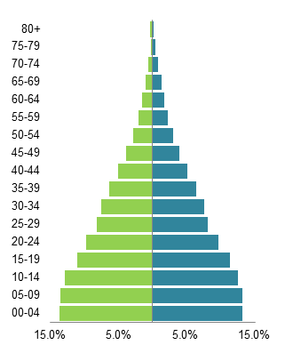
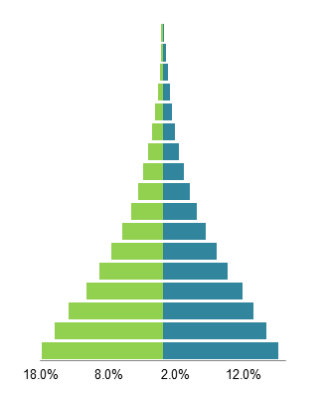
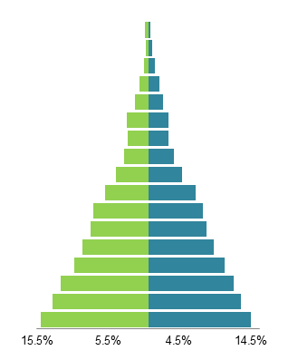
Kenya
Rwanda
Uganda
Age Group
% of Total Population

*Data from World Bank, World Development Indicators, 2017 - 2019

** Data from World Health Organisation, Global Health Observatory data repository, 2016
- The world’s population is aging but Uganda, Kenya and Rwanda have relatively young population. The median age in Uganda is 15.9 years and Uganda is considered as one of the youngest populations in the world. Among the three countries, Uganda has lowest life expectancy at birth.

- Table 3.2 shows the comparison of life expectancy in various ages (every 5 years) between Uganda and Kenya.

Table 3.2 Life Expectancy at Various Ages*
Life  Expectancy | Male | Female | Male | Female
Life  Expectancy | Uganda |  | Kenya
AT BIRTH | 60.2 | 64.8 | 64.4 | 68.9
AGE 5 | 58.9 | 63.1 | 63 | 67.2
AGE 10 | 54.6 | 58.8 | 58.6 | 62.6
AGE 15 | 50.0 | 54.2 | 53.9 | 57.9
AGE 20 | 45.9 | 49.9 | 49.5 | 53.3
AGE 25 | 41.9 | 45.6 | 45.3 | 48.8
AGE 30 | 37.9 | 41.5 | 41.1 | 44.4
AGE 35 | 34.1 | 37.4 | 37.0 | 40.0
AGE 40 | 30.4 | 33.4 | 32.9 | 35.8
AGE 45 | 26.8 | 29.4 | 29 | 31.7
AGE 50 | 23.2 | 25.4 | 25.1 | 27.5
AGE 55 | 19.8 | 21.5 | 21.4 | 23.4
AGE 60 | 16.3 | 17.7 | 17.7 | 19.4
AGE 65 | 13.1 | 14.2 | 14.3 | 15.6
AGE 70 | 10.3 | 11.1 | 11.2 | 12.2
AGE 75 | 7.7 | 8.4 | 8.4 | 9.2
AGE 80 | 5.7 | 6.2 | 6.2 | 6.7
AGE 85 | 4.1 | 4.5 | 4.4 | 4.9

** Data from World Health Organisation, Global Health Observatory data repository, 2016

- Table 3.3 shows the top 10 causes of (crude) deaths in 2019 among Uganda, Kenya and Rwanda. The death causes are similar among the countries, which the top cause of death being neonatal conditions, followed by respiratory (lower respiratory infections) and cardiovascular (ischaemic heart disease, stroke). Other than that, the top causes of death also include communicable diseases which are HIV/ AIDS, Malaria and tuberculosis.

Table 3.3 Top 10 Causes of Total Number of (Crude) Deaths in 2019*
Uganda |  | Kenya |  | Rwanda
Neonatal conditions |  | Neonatal conditions |  | Neonatal conditions
HIV / AIDS |  | Lower respiratory infections |  | Lower respiratory infections
Lower respiratory infections |  | HIV / AIDS |  | Stroke
Malaria |  | Tuberculosis |  | Road Injury
Road Injury |  | Stroke |  | Ischamic heart disease
Diarrhoeal diseases |  | Diarrhoeal diseases |  | Malaria
Stroke |  | Road Injury |  | Diarrhoeal diseases
Ischamic heart disease |  | Cirrhosis of the liver |  | HIV / AIDS
Tuberculosis |  | Malaria |  | Cirrhosis of the liver
Congenital anomalies |  | Ischamic heart disease |  | Diabetes mellitus

* Data from World Health Organisation, Global Health Observatory data repository, 2019

The crude death rates for the top 10 causes of death is similar between Uganda (314.88 per 100,000 population) and Kenya (315.18 per 100,000 population), compared to Rwanda (297.40 per 100,000 population)

- We understand that the type of life insurance products sold in these countries is similar (i.e. mainly on Savings and Protection plans). For savings plans, the impact of variations in mortality is not that significant on the pricing and valuation. We have carried out a sensitivity analysis on one of the popular savings products in Uganda. By increasing the mortality assumption by 20%, the reserves change by less than 1%. This shows that the products are not sensitive to the mortality assumptions.

Male

- Table 3.4 shows the comparison of actual mortality rates by five-year group for Individual policies and the corresponding population mortality rates for Uganda.

Table3.4: Comparison of Mortality Rates between All Male Assured Lives (Crude), and All Male Population in Uganda

 | Rates of Mortality |  |  |  |  | Ratios
Age Group |  | All Male  Assured Crude  2015/19 | All Male  Population  2016** |  |  |  | (1) Vs (2)
 |  | (1) | (2) | (3) |  |  | (4)
20-24 |  | - | 0.00465 | * |  |  | -100%
25-29 |  | 0.00040 | 0.00539 | * |  |  | -93%
30-34 |  | 0.00027 | 0.00644 | * |  |  | -96%
35-39 |  | 0.00077 | 0.00817 |  |  |  | -91%
40-44 |  | 0.00105 | 0.00960 |  |  |  | -89%
45-49 |  | 0.00114 | 0.01122 |  |  |  | -90%
50-54 |  | 0.00099 | 0.01441 |  |  |  | -93%
55-59 |  | 0.00238 | 0.01734 | * |  |  | -86%
60-64 |  | 0.00088 | 0.02430 | * |  |  | -96%
65-69 |  | - | 0.03560 | * |  |  | -100%
70-74 |  | - | 0.05442 | * |  |  | -100%
75-79 |  | - | 0.08404 | * |  |  | -100%
80-84 |  | - | 0.12796 | * |  |  | -100%
85+ |  | - | 0.33333 | * |  |  | -100%

* Ratio based on 10 actual deaths or fewer

** Data from World Health Organisation, Global Health Observatory data repository

- The mortality experience of male lives during 2015 to 2019 is significantly lower from the population mortality experience during the same period. This is mainly due to small sample size used in derivation of crude assured lives mortality rates.

- Table 3.5 shows the comparison of mortality rates between the All Males Assured Lives and All Males Population in Kenya and Rwanda. The tables are followed by graph showing the similar comparison.

Table 3.5: Comparison of Mortality Rates between All Male Assured Lives and All Male Population in Kenya and Rwanda

 | Rates of Mortality |  | Ratios |  | Rates of Mortality |  | Ratios
 | All Male Assured KE07-10 | All Male Population Kenya | (1) vs (2) |  | All Male Assured Rwanda | All Male Population Rwanda | (4) vs (5)
 | 2015/19 | 2016** |  |  | 2015/19 | 2016**
 | (1) | (2) | (3) |  | (4) | (5) | (6
20-24 | 0.00163 | 0.00332 | -51% |  | 0.00089 | 0.00310 | -71%
25-29 | 0.00197 | 0.00366 | -46% |  | 0.00107 | 0.00322 | -67%
30-34 | 0.00182 | 0.00428 | -58% |  | 0.00139 | 0.00361 | -62%
35-39 | 0.00199 | 0.00561 | -65% |  | 0.00192 | 0.00420 | -54%
40-44 | 0.00258 | 0.00694 | -63% |  | 0.00273 | 0.00524 | -48%
45-49 | 0.00312 | 0.00832 | -62% |  | 0.00392 | 0.00667 | -41%
50-54 | 0.00354 | 0.01097 | -68% |  | 0.00560 | 0.00959 | -42%
55-59 | 0.00477 | 0.01332 | -64% |  | 0.00785 | 0.01277 | -39%
60-64 | 0.00860 | 0.01945 | -56% |  | 0.01140 | 0.01930 | -41%
65-69 | 0.01550 | 0.02947 | -47% |  | 0.01873 | 0.02965 | -37%
70-74 | 0.02784 | 0.04576 | -39% |  | 0.03160 | 0.04643 | -32%
75-79 | 0.04961 | 0.07286 | -32% |  | 0.05355 | 0.07373 | -27%
80-84 | 0.08727 | 0.11400 | -23% |  | 0.09015 | 0.11553 | -22%
85+ | 0.18522 | 0.33333 | -44% |  | 0.17659 | 0.33334 | -47%

** Data from World Health Organisation, Global Health Observatory data repository

Graph 3.2: Comparison of Mortality Rates between All Male Assured Lives (A) and All Male Population (P) in Kenya and Rwanda

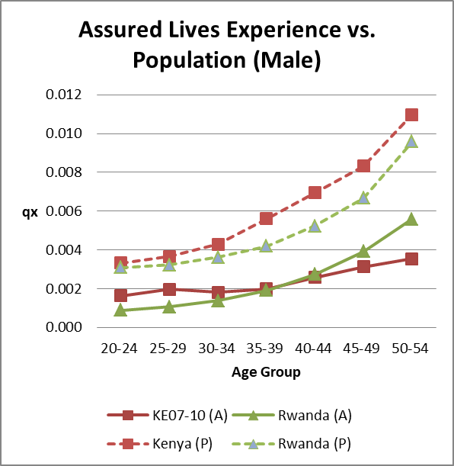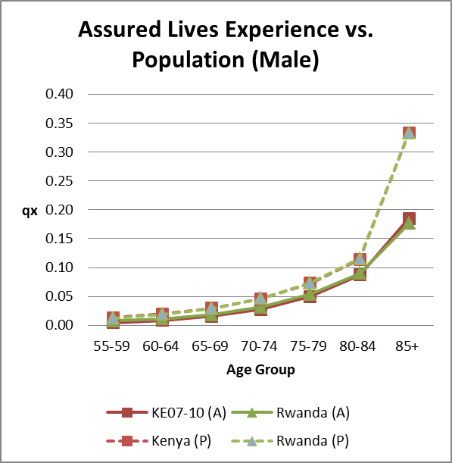

- Based on the assured lives mortality rates and the corresponding population mortality rates for Kenya and Rwanda, we noted that the reasonable range of assured lives mortality rates for Males are 45%-65% lower than the population mortality rates.

- The life expectancy of All Male Population at age 20 are as follows:

Table3.6: Life Expectancy of All Male Population** at Age 20 between Uganda, Kenya and Rwanda
Life Expectancy at Age 20
Uganda | Kenya | Rwanda
45.1 | 48.7 | 49.7

**Derived using 2016 data from World Health Organisation, Global Health Observatory data repository

Uganda Male has lower life expectancy compared to Male in Kenya and Rwanda.

Female

- Table 3.7 shows the comparison of actual mortality rates by five-year group for Individual policies and the corresponding population mortality rates for Uganda.

Table 3.7: Comparison of Mortality Rates between All Female Assured Lives (Crude), and All Female Population in Uganda
 |  | Rates of Mortality |  |  |  | Ratios
Age Group | All Female  Assured Crude  2015/19 |  | All Female  Population  2016** |  |  |  | (1) Vs (2)
 | (1) |  | (2) |  | (3) |  | (4)
20-24 | 0.00056 |  | 0.00333 |  | * |  | -83%
25-29 | 0.00102 |  | 0.00403 |  | * |  | -75%
30-34 | 0.00052 |  | 0.00464 |  | * |  | -89%
35-39 | 0.00044 |  | 0.00537 |  | * |  | -92%
40-44 | 0.00053 |  | 0.00645 |  | * |  | -92%
45-49 | 0.00105 |  | 0.00733 |  | * |  | -86%
50-54 | 0.00065 |  | 0.00954 |  | * |  | -93%
55-59 | 0.00132 |  | 0.01234 |  | * |  | -89%
60-64 | 0.00106 |  | 0.01845 |  | * |  | -94%
65-69 | - |  | 0.02908 |  | * |  | -100%
70-74 | - |  | 0.04686 |  | * |  | -100%
75-79 | - |  | 0.07432 |  | * |  | -100%
80-84 | - |  | 0.11667 |  | * |  | -100%
85+ | - |  | 0.33333 |  | * |  | -100%

* Ratio based on 10 actual deaths or fewer

** Data from World Health Organisation, Global Health Observatory data repository
- All age group has less than 10 death and this results in the experience significantly lower from the population mortality experience during the same period.

- Table 3.8 shows the comparison of mortality rates between the All Females Assured Lives and All Females Population in Kenya and Rwanda. The tables are followed by graph showing similar comparison.

Table 3.8: Comparison of Mortality Rates between All Female Assured Lives and All Female Population in Kenya and Rwanda

 | Rates of Mortality |  | Ratios |  | Rates of Mortality |  | Ratios
 | All Female Assured KE07-10 | All Female Population Kenya | (1) vs (2) |  | All Female Assured Rwanda | All Female Population Rwanda | (4) vs (5)
 | 2015/19 | 2016** |  |  | 2015/19 | 2016**
 | (1) | (2) | (3) |  | (4) | (5) | (6
20-24 | 0.00165 | 0.00207 | -20% |  | 0.00053 | 0.00184 | -71%
25-29 | 0.00173 | 0.00256 | -33% |  | 0.00064 | 0.00224 | -71%
30-34 | 0.00140 | 0.00301 | -53% |  | 0.00084 | 0.00267 | -69%
35-39 | 0.00135 | 0.00407 | -67% |  | 0.00122 | 0.00345 | -65%
40-44 | 0.00170 | 0.00511 | -67% |  | 0.00182 | 0.00440 | -59%
45-49 | 0.00262 | 0.00572 | -54% |  | 0.00272 | 0.00527 | -48%
50-54 | 0.00434 | 0.00738 | -41% |  | 0.00407 | 0.00708 | -43%
55-59 | 0.00718 | 0.00918 | -22% |  | 0.00595 | 0.00934 | -36%
60-64 | 0.01186 | 0.01388 | -15% |  | 0.00899 | 0.01432 | -37%
65-69 | 0.01955 | 0.02249 | -13% |  | 0.01535 | 0.02328 | -34%
70-74 | 0.03211 | 0.03739 | -14% |  | 0.02689 | 0.03887 | -31%
75-79 | 0.05242 | 0.06195 | -15% |  | 0.04723 | 0.06383 | -26%
80-84 | 0.08479 | 0.10190 | -17% |  | 0.08229 | 0.10473 | -21%
85+ | 0.16799 | 0.33333 | -50% |  | 0.17050 | 0.33333 | -49%

** Data from World Health Organisation, Global Health Observatory data repository

Graph 3.3: Comparison of Mortality Rates between All Female Assured Lives (A) and All Female Population (P) in Kenya and Rwanda

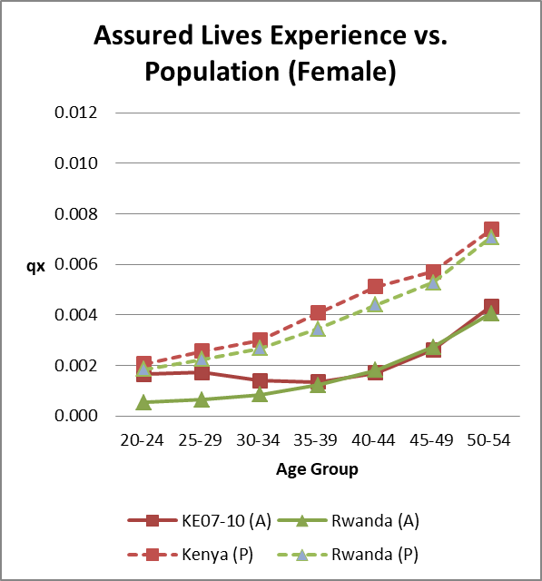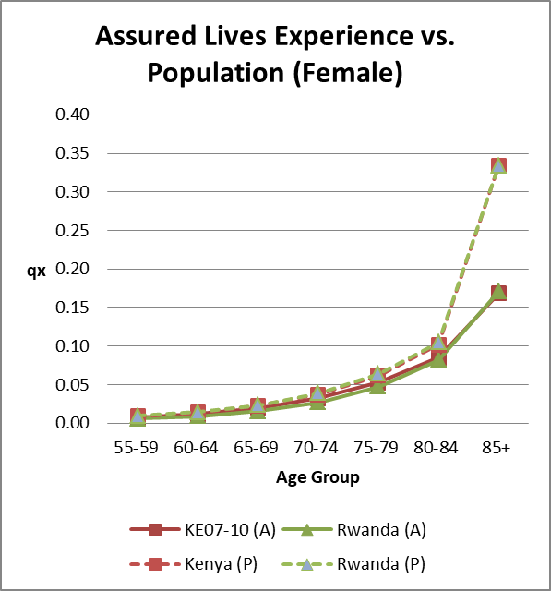

- Based on the assured lives mortality rates and the corresponding population mortality rates for Kenya and Rwanda, we noted that the reasonable range of assured lives mortality rates for Females are 40%-70% lower than the population mortality rates.

- The life expectancy of All Female Population at age 20 are as follows:

Table 3.9: Life Expectancy of All Female Population** at Age 20 between Uganda, Kenya and Rwanda

Life Expectancy at Age 20
Uganda | Kenya | Rwanda
49.0 | 52.1 | 52.5

**Derived using 2016 data from World Health Organisation, Global Health Observatory data repository

Uganda Female has lower life expectancy compared to Female in Kenya and Rwanda.

Development of Mortality Table for Uganda

  - This section describes the methods we applied to the mortality crude rates to produce a smooth graduated mortality table.

  - Based on the earlier section, we have concluded that the data collected is far below the threshold required to construct a mortality table. The Final Data cannot be used solely to represent the mortality experience of assured lives in Uganda. We have therefore chosen the graduation methods which take into account the data limitation that we have, and make reference to the information we have presented in the previous sections of the report.

  - The graduation methods considered in this study are as follows:
  - Brass Logit
  - Coale Kisker

Method of Graduation

  - Table 5.1 shows the graduation methods used for different age band for Males and Females:

Table 5.1: Graduation Methods for Males and Females
Age range | Male
20 – 60 | Brass Logit
61 – 99 | Coale Kisker
 | Female
20 – 50 | Brass Logit
51 – 99 | Coale Kisker

  - Brass Logit Method

Most of the graduation methods involve fitting of a smooth curve using the crude mortality rates. Due to the limited data we have, there are many ages where we do not have any experience. Therefore, we need a graduation method which assumes that the lives under this mortality investigation have similar structure as a standard mortality table.

Brass Logit assumes that the transformation of probabilities of survival to age x and the corresponding probabilities for different life tables are approximately linear.

The formula used was

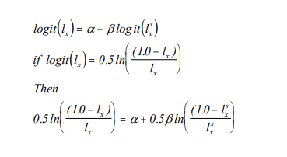
l_{x} is the proportion of survival at age x based on the investigation data
l^{s}_{x} is the proportion of survival at age x based on the standard table
α is the constant which can be used to adjust the overall level of the mortality table
β is the constant which can be used to change the slope of the mortality table

We have chosen Kenya Assured Lives KE07-10 table as the standard table due to similarities between Kenya and Uganda population. Adjustments have been made to the α factor for both Male and Female tables, based on our knowledge of the mortality patterns between Uganda and Kenya.

  - Coale Kisker Method

Coale Kisker method assumes a steady decrease in the rate of increase in mortality in high ages. In other words, contrary to the usual constant exponential rate adopted by Gompertz and Makeham law, the method assumes the exponential rate of mortality to decline linearly.

The method extrapolates the mortality rates based on mortality rates around a chosen age t, and provides a closure to the life table at a chosen target age, ω.
For x ≥ t, define k(x) = k (x-1) – R, where k(x) = ln (q_{x}/q_{x-1})

Extending the formula up to age ω yields

k(t) = k(t-1) – R
k(t+1)=k(t-1) – 2R
.
.
.
k(ω)=k(t-1) – (ω – t +1)R

Summing up the above formula, yield the following
k(t)+…+k(ω)= (ω – t +1) x k(t-1) – R (1+2+…+( ω – t )+ ( ω – t +1 ))
ln(q_{ω}) – ln(q_{t-1})= (ω – t +1) x k(t-1) – R (1+2+…+( ω – t )+ ( ω – t +1 ))

Solving for R, we obtain

R={(ω – t +1 ) k(t-1) + ln (q_{t-1}) - ln(q_{ω})}/(1+2+…+( ω – t )+ ( ω – t +1 ))

The method allows the selection of a target mortality rate for a target age, ω. This ensures the rate of increase at the oldest ages is not abrupt and a smooth closure of a life table can be obtained.

For this mortality investigation, we have a target mortality rate of 1 for age 115 for both Male and Female.

5. Graduation Results

- This section summarises the graduated mortality table for lives assured in Uganda during the five year period ended 31 December 2019.

Graduation Results

- Annexure 1 and 2 show the raw and graduated mortality rates for lives assured in Uganda during the five year period ended 31 December 2019. The comparison between Male graduated rates, raw rates, KE07-10 rates are shown below.

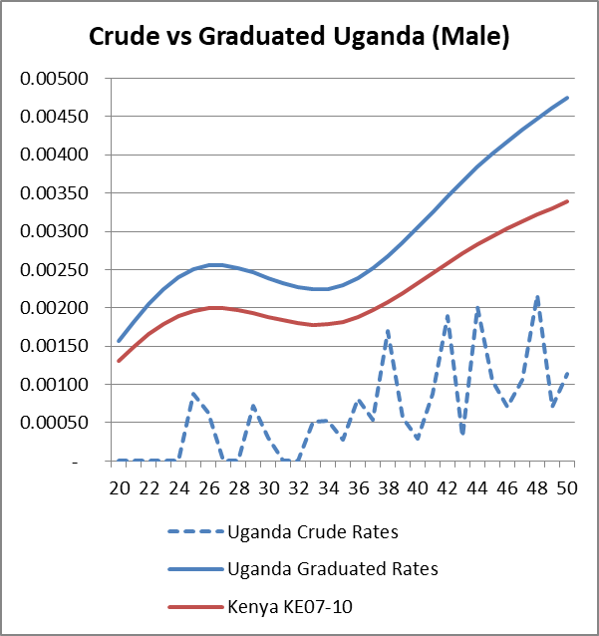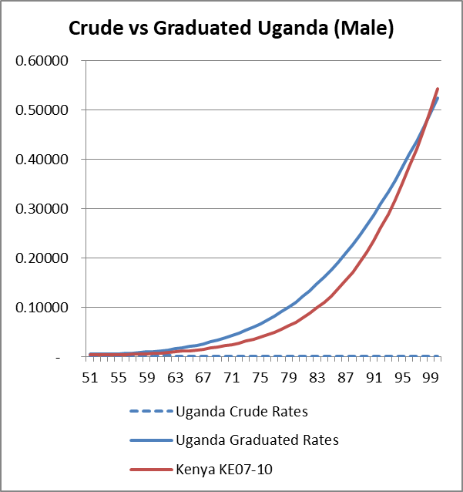
- The comparison between Female graduated rates, raw rates, KE07-10 rates are shown below.

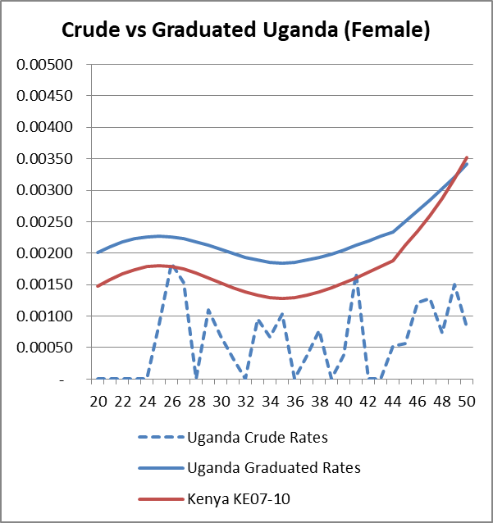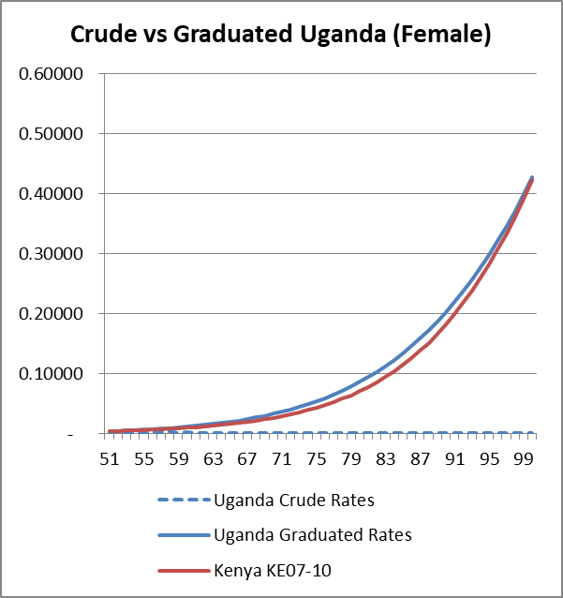

- The graph below shows the comparison between Male and Female graduated rates.

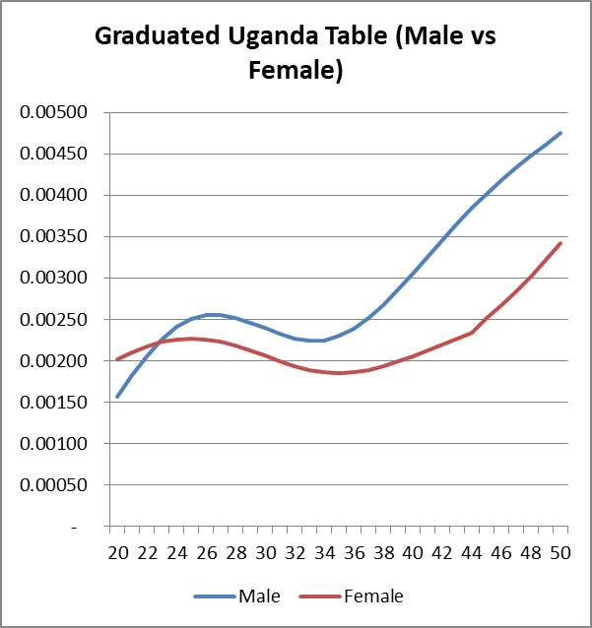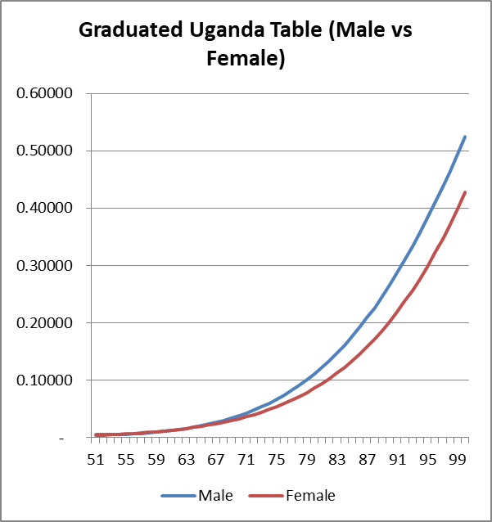

6. Comparison of Uganda Assured Lives Table

- The mortality experience for Uganda Assured Lives table is compared to the mortality experience for the published mortality tables around the region, in particularly from Kenya and Rwanda.

- We have selected two published mortality tables for comparison purposes. These tables are:

- KE 2007-2010 Mortality Tables for Assured Lives in Kenya.
- Rwanda Mortality Table 2012 - 2016.

Annexure 3 shows the complete mortality tables for Kenya and Rwanda.

Male

- Table 6.1 shows the actual mortality rates by five-year age group, and the corresponding mortality rates of KE 2007-2010 and Rwanda Mortality Table 2012-2016 for the exposed to risk in the same age group and the corresponding ratios. A graph of these mortality rates is presented on the following pages.

Table 6.1: Comparison of Graduated Mortality Rates against KE2007-2010 and Rwanda Mortality Tables

 | Rates of Mortality |  |  |  | Ratios
Age Group |  | Uganda Graduated | KE2007-10 | Rwanda |  | (1) Vs (2) | (1) Vs (3)
 |  | (1) | (2) | (3) |  | (4) | (5)
20-24 |  | 0.002018 | 0.001628 | 0.000889 |  | 24% | 127%
25-29 |  | 0.002519 | 0.001971 | 0.001067 |  | 28% | 136%
30-34 |  | 0.002295 | 0.00182 | 0.001386 |  | 26% | 66%
35-39 |  | 0.002546 | 0.001988 | 0.001919 |  | 28% | 33%
40-44 |  | 0.003450 | 0.002578 | 0.002733 |  | 34% | 26%
45-49 |  | 0.004321 | 0.003125 | 0.003917 |  | 38% | 10%
50-54 |  | 0.005004 | 0.003543 | 0.005597 |  | 41% | -11%
55-59 |  | 0.007103 | 0.004773 | 0.007854 |  | 49% | -10%
60-64 |  | 0.013970 | 0.008598 | 0.011396 |  | 62% | 23%
65-69 |  | 0.026421 | 0.015502 | 0.018727 |  | 70% | 41%
70-74 |  | 0.047494 | 0.027835 | 0.031602 |  | 71% | 50%
75-79 |  | 0.081084 | 0.04961 | 0.053546 |  | 63% | 51%
80-84 |  | 0.131422 | 0.087268 | 0.090151 |  | 51% | 46%
85+ |  | 0.226165 | 0.185216 | 0.176593 |  | 22% | 28%

Graph 6.1: Comparison of Graduated Mortality Rates against KE2007-2010 and Rwanda Mortality Tables

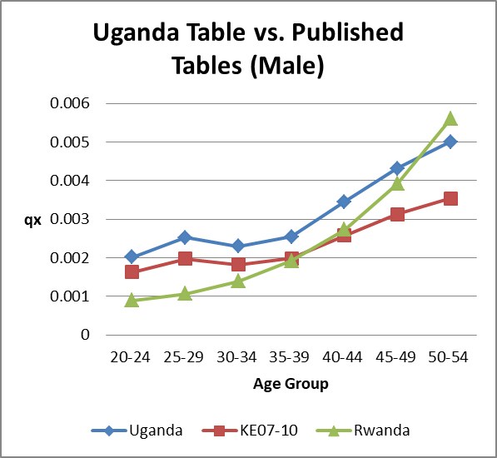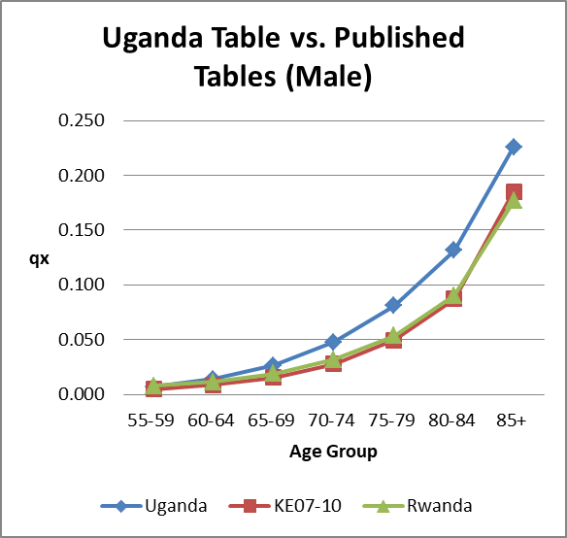

- The graph below shows the comparison of assured lives tables and population table for Uganda, Kenya and Rwanda.

Graph 6.2: Comparison of Assured Lives Mortality Rates (A) against Population Mortality Tables (P)**

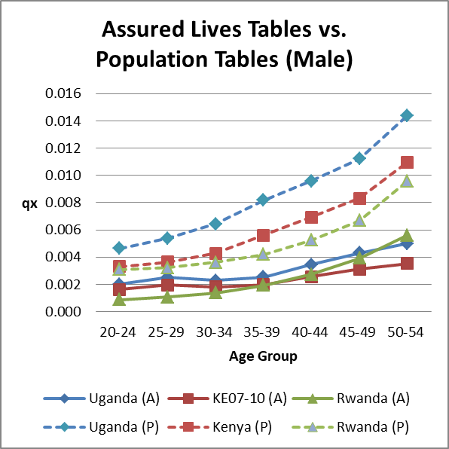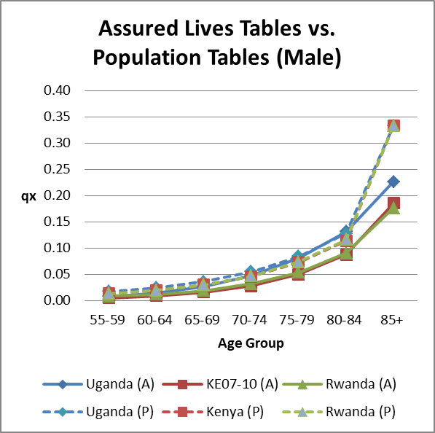

**Derived using data from World Health Organisation, Global Health Observatory data repository
- The Table below show the life expectancy at age 20.

Table 6.2: Life Expectancy for Male at age 20

 | Life Expectancy at Age 20
 | Uganda | Kenya | Rwanda
Population Table** | 45.1 | 48.7 | 49.7
Assured Lives Table | 52.6 | 57.0 | 56.2

**Derived using 2016 data from World Health Organisation, Global Health Observatory data repository

Female

- Table 6.3 shows the actual mortality rates by five-year age group, and the corresponding mortality rates of KE 2007-2010 and Rwanda Mortality Table 2012-2016 for the exposed to risk in the same age group and the corresponding ratios. A graph of these mortality rates is presented on the following pages.

Table 6.3: Comparison of Graduated Mortality Rates against KE2007-2010 and Rwanda Mortality Tables

Age | Rates of Mortality |  |  | Ratios
Group | Female | Female | Female | (1) Vs (2) | (1) Vs (3)
 | Uganda Crude | KE2007-10 | Rwanda | (1) Vs (2) | (1) Vs (3)
 | (1) | (2) | (3) | (4) | (5)
20-24 | 0.002156 | 0.001654 | 0.000534 | 30% | 304%
25-29 | 0.002213 | 0.001725 | 0.000640 | 28% | 246%
30-34 | 0.001947 | 0.001400 | 0.000839 | 39% | 132%
35-39 | 0.001902 | 0.001347 | 0.001215 | 41% | 57%
40-44 | 0.002193 | 0.001702 | 0.001816 | 29% | 21%
45-49 | 0.002850 | 0.002622 | 0.002724 | 9% | 5%
50-54 | 0.004419 | 0.004341 | 0.004065 | 2% | 9%
55-59 | 0.007988 | 0.007180 | 0.005947 | 11% | 34%
60-64 | 0.014050 | 0.011860 | 0.008987 | 18% | 56%
65-69 | 0.024038 | 0.019548 | 0.015353 | 23% | 57%
70-74 | 0.039986 | 0.032105 | 0.026890 | 25% | 49%
75-79 | 0.064649 | 0.052423 | 0.047226 | 23% | 37%
80-84 | 0.101533 | 0.084793 | 0.082288 | 20% | 23%
85+ | 0.183407 | 0.167988 | 0.170505 | 9% | 8%

Graph 6.3: Comparison of Graduated Mortality Rates against KE2007-2010 and Rwanda Mortality Tables

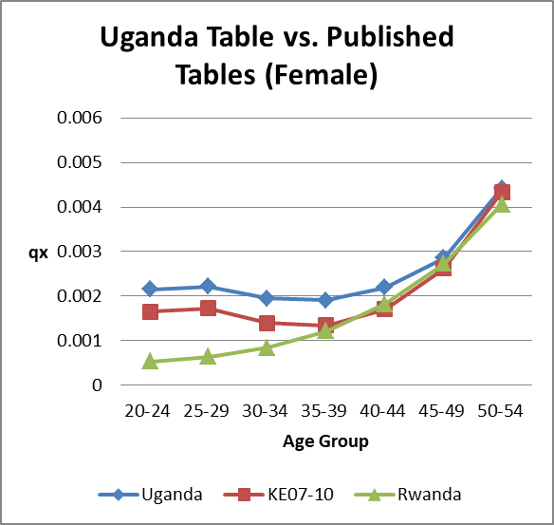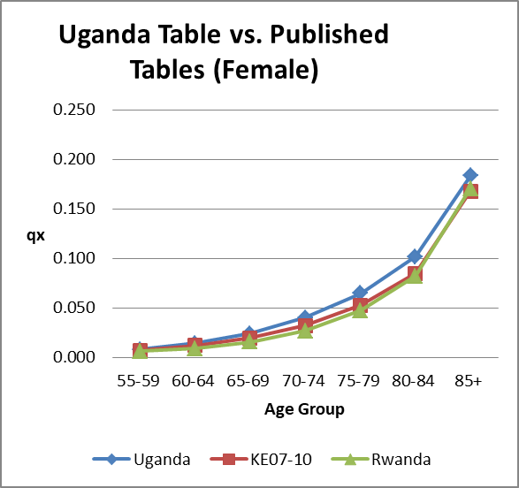

- The graph below shows the comparison of assured lives tables and population table for Uganda, Kenya and Rwanda.

Graph 6.4: Comparison of Assured Lives Mortality Rates against Population Mortality Tables**

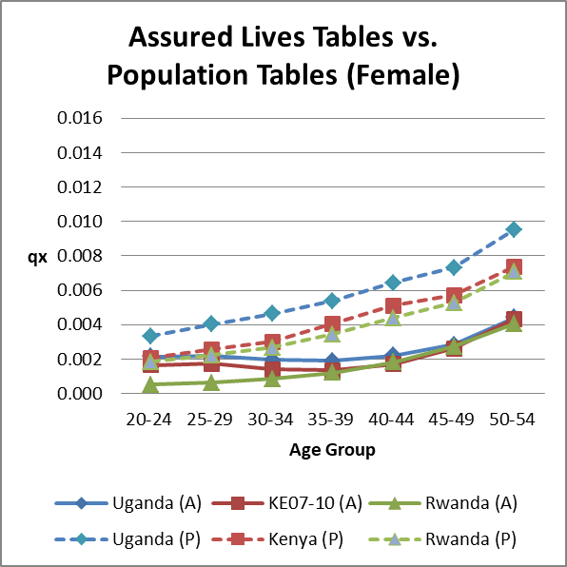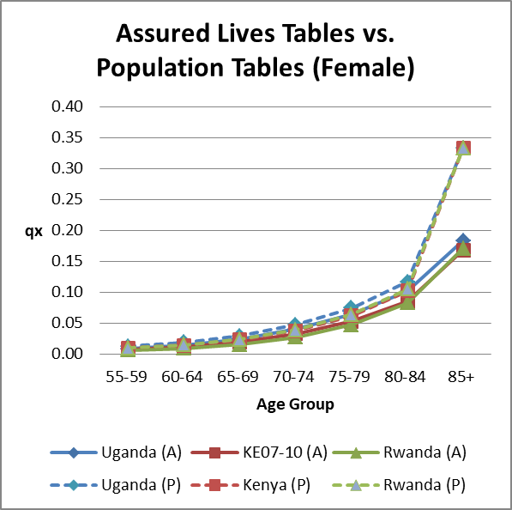
- The Table below show the life expectancy at age 20.

Table 6.4: Life Expectancy for Female at age 20

 | Life Expectancy at Age 20
 | Uganda | Kenya | Rwanda
Population Table** | 49.0 | 52.1 | 52.5
Assured Lives Table | 54.1 | 56.6 | 58.4

**Derived using 2016 data from World Health Organisation, Global Health Observatory data repository

7. Summary and Recommendations

- This is the first mortality table for Uganda Assured Lives. The data collected through this project is far below the threshold required to construct a mortality table. We have therefore chosen graduation methods which take into account the data limitation that we have, and adjust the table based on information we gathered on the mortality experience of the Uganda population.

- The data from group business has been excluded in the study due to lack of gender and age information for majority part of the business.

We recommend the companies to start collecting crucial information from now onwards so that more data can be used in the next mortality study. The full list of crucial fields can be found in Annexure 4.

- Only 1 company offer longevity product and no death claim has been recorded. Therefore there is no data available to build a separate mortality table for longevity product.

For countries that do not have annuitant mortality table, it is common for the insurers to take two years setback using the assured lives mortality table. Therefore, companies may consider applying two years setback of the Uganda Mortality Table for longevity product.

- Given that majority of the products sold in Uganda is savings products with low surrender value at initial duration, variation in mortality would not have significant impact to profitability and reserving. On the other hand, high lapses may have a much higher impact on profitability compared to mortality.

- We recommend the industry to redo the mortality experience analysis once there is sufficient data collected.

ANNEXURE 1

MALE - RAW AND GRADUATED RATES

AGE | EXPOSURE | CLAIMS | RAW | GRADUATED
20 | 154.0 | - | - | 0.001563
21 | 262.0 | - | - | 0.001822
22 | 364.5 | - | - | 0.002053
23 | 521.5 | - | - | 0.002251
24 | 792.0 | - | - | 0.002405
25 | 1,132.0 | 1.0 | 0.000883 | 0.002508
26 | 1,589.0 | 1.0 | 0.000629 | 0.002554
27 | 2,031.5 | - | - | 0.002554
28 | 2,355.0 | - | - | 0.002520
29 | 2,796.5 | 2.0 | 0.000715 | 0.002461
30 | 3,283.0 | 1.0 | 0.000305 | 0.002393
31 | 3,531.5 | - | - | 0.002325
32 | 3,700.0 | - | - | 0.002270
33 | 3,901.0 | 2.0 | 0.000513 | 0.002239
34 | 3,779.5 | 2.0 | 0.000529 | 0.002246
35 | 3,677.5 | 1.0 | 0.000272 | 0.002297
36 | 3,701.5 | 3.0 | 0.000810 | 0.002390
37 | 3,677.5 | 2.0 | 0.000544 | 0.002518
38 | 3,522.5 | 6.0 | 0.001703 | 0.002674
39 | 3,518.5 | 2.0 | 0.000568 | 0.002855
40 | 3,496.0 | 1.0 | 0.000286 | 0.003049
41 | 3,400.5 | 3.0 | 0.000882 | 0.003253
42 | 3,171.5 | 6.0 | 0.001892 | 0.003458
43 | 3,104.5 | 1.0 | 0.000322 | 0.003656
44 | 2,988.0 | 6.0 | 0.002008 | 0.003843
45 | 2,860.5 | 3.0 | 0.001049 | 0.004015
46 | 2,829.5 | 2.0 | 0.000707 | 0.004177
47 | 2,824.0 | 3.0 | 0.001062 | 0.004330
48 | 2,770.5 | 6.0 | 0.002166 | 0.004475
49 | 2,802.0 | 2.0 | 0.000714 | 0.004613
50 | 2,624.0 | 3.0 | 0.001143 | 0.004746
51 | 2,464.5 | - | - | 0.004877
52 | 2,166.0 | 2.0 | 0.000923 | 0.005006
53 | 2,034.5 | 4.0 | 0.001966 | 0.005135
54 | 1,876.5 | 2.0 | 0.001066 | 0.005264
55 | 1,658.5 | 4.0 | 0.002412 | 0.005394
56 | 1,533.5 | 4.0 | 0.002608 | 0.006056

AGE | EXPOSURE | CLAIMS | RAW | GRADUATED
57 | 1,389.0 | 4.0 | 0.002880 | 0.006958
58 | 1,333.0 | 2.0 | 0.001500 | 0.007991
59 | 1,224.0 | 3.0 | 0.002451 | 0.009178
60 | 998.0 | - | - | 0.010542
61 | 639.5 | 1.0 | 0.001564 | 0.012059
62 | 328.5 | 1.0 | 0.003044 | 0.013796
63 | 193.0 | - | - | 0.015751
64 | 123.0 | - | - | 0.017947
65 | 80.5 | - | - | 0.020409
66 | 19.0 | - | - | 0.023163
67 | 5.5 | - | - | 0.026236
68 | 2.5 | - | - | 0.029657
69 | 1.5 | - | - | 0.033459
70 | 0.5 | - | - | 0.037672
71 | 1.0 | - | - | 0.042332
72 | 0.5 | - | - | 0.047474
73 | - | - | - | 0.053134
74 | - | - | - | 0.059351
75 | - | - | - | 0.066164
76 | 0.5 | - | - | 0.073612
77 | - | - | - | 0.081736
78 | - | - | - | 0.090577
79 | 1.0 | - | - | 0.100174
80 | 2.0 | - | - | 0.110567
81 | 1.0 | - | - | 0.121797
82 | 1.0 | - | - | 0.133901
83 | 0.5 | - | - | 0.146915
84 | - | - | - | 0.160874
85 | - | - | - | 0.175809
86 | - | - | - | 0.191748
87 | - | - | - | 0.208717
88 | - | - | - | 0.226737
89 | - | - | - | 0.245823
90 | - | - | - | 0.265986
91 | - | - | - | 0.287231
92 | - | - | - | 0.309556
93 | - | - | - | 0.332954
94 | - | - | - | 0.357409
95 | - | - | - | 0.382898

AGE | EXPOSURE | CLAIMS | RAW | GRADUATED
96 | - | - | - | 0.409390
97 | - | - | - | 0.436845
98 | - | - | - | 0.465214
99 | - | - | - | 0.494442
100 | - | - | - | 0.524462

ANNEXURE 2

FEMALE - RAW AND GRADUATED RATES

AGE | EXPOSURE | CLAIMS | RAW | GRADUATED
20 | 101.0 | - | - | 0.002015
21 | 175.5 | 1.0 | 0.005698 | 0.002103
22 | 258.5 | - | - | 0.002174
23 | 468.5 | - | - | 0.002227
24 | 774.0 | - | - | 0.002260
25 | 1,142.0 | 1.0 | 0.000876 | 0.002272
26 | 1,630.0 | 3.0 | 0.001840 | 0.002259
27 | 1,957.5 | 3.0 | 0.001533 | 0.002228
28 | 2,326.0 | - | - | 0.002180
29 | 2,718.0 | 3.0 | 0.001104 | 0.002123
30 | 2,957.5 | 2.0 | 0.000676 | 0.002060
31 | 3,063.5 | 1.0 | 0.000326 | 0.001995
32 | 3,123.5 | - | - | 0.001936
33 | 3,132.5 | 3.0 | 0.000958 | 0.001888
34 | 3,014.0 | 2.0 | 0.000664 | 0.001857
35 | 2,896.0 | 3.0 | 0.001036 | 0.001847
36 | 2,816.0 | - | - | 0.001858
37 | 2,667.0 | 1.0 | 0.000375 | 0.001888
38 | 2,597.5 | 2.0 | 0.000770 | 0.001932
39 | 2,626.0 | - | - | 0.001988
40 | 2,582.0 | 1.0 | 0.000387 | 0.002052
41 | 2,375.5 | 4.0 | 0.001684 | 0.002121
42 | 2,265.0 | - | - | 0.002194
43 | 2,108.0 | - | - | 0.002266
44 | 1,900.5 | 1.0 | 0.000526 | 0.002336
45 | 1,752.5 | 1.0 | 0.000571 | 0.002512
46 | 1,651.5 | 2.0 | 0.001211 | 0.002671
47 | 1,553.5 | 2.0 | 0.001287 | 0.002840
48 | 1,360.5 | 1.0 | 0.000735 | 0.003021
49 | 1,333.5 | 2.0 | 0.001500 | 0.003213
50 | 1,221.0 | 1.0 | 0.000819 | 0.003417
51 | 1,016.0 | - | - | 0.003861
52 | 854.0 | 1.0 | 0.001171 | 0.004362
53 | 784.5 | - | - | 0.004924
54 | 717.0 | 1.0 | 0.001395 | 0.005551
55 | 677.5 | - | - | 0.006252
56 | 633.0 | 1.0 | 0.001580 | 0.007033

AGE | EXPOSURE | CLAIMS | RAW | GRADUATED
57 | 613.0 | 1.0 | 0.001631 | 0.007903
58 | 596.0 | 2.0 | 0.003356 | 0.008872
59 | 508.0 | - | - | 0.009948
60 | 408.0 | 1.0 | 0.002451 | 0.011143
61 | 273.0 | - | - | 0.012468
62 | 135.0 | - | - | 0.013936
63 | 77.5 | - | - | 0.015559
64 | 54.0 | - | - | 0.017352
65 | 34.5 | - | - | 0.019331
66 | 7.0 | - | - | 0.021513
67 | 1.0 | - | - | 0.023915
68 | - | - | - | 0.026556
69 | - | - | - | 0.029457
70 | - | - | - | 0.032639
71 | - | - | - | 0.036126
72 | - | - | - | 0.039942
73 | - | - | - | 0.044113
74 | 1.0 | - | - | 0.048667
75 | 2.5 | - | - | 0.053633
76 | 1.5 | - | - | 0.059042
77 | - | - | - | 0.064925
78 | - | - | - | 0.071318
79 | 1.0 | - | - | 0.078255
80 | 1.0 | - | - | 0.085773
81 | 2.5 | - | - | 0.093912
82 | 2.0 | - | - | 0.102712
83 | 1.0 | - | - | 0.112215
84 | - | - | - | 0.122464
85 | - | - | - | 0.133504
86 | - | - | - | 0.145382
87 | - | - | - | 0.158144
88 | - | - | - | 0.171841
89 | - | - | - | 0.186521
90 | - | - | - | 0.202236
91 | - | - | - | 0.219038
92 | - | - | - | 0.236978
93 | - | - | - | 0.256109
94 | - | - | - | 0.276485
95 | - | - | - | 0.298158

AGE | EXPOSURE | CLAIMS | RAW | GRADUATED
96 | - | - | - | 0.321182
97 | - | - | - | 0.345608
98 | - | - | - | 0.371490
99 | - | - | - | 0.398876
100 | - | - | - | 0.427817

ANNEXURE 3

KE 2007-2010 Mortality Tables for Assured Lives in Kenya
AGE | MALE | FEMALE | AGE | MALE | FEMALE | AGE | MALE | FEMALE
16 | 0.000448 | 0.000946 | 44 | 0.002827 | 0.001885 | 72 | 0.027633 | 0.031992
17 | 0.000675 | 0.001088 | 45 | 0.002935 | 0.002123 | 73 | 0.031068 | 0.035333
18 | 0.000897 | 0.001227 | 46 | 0.003036 | 0.002348 | 74 | 0.034922 | 0.039015
19 | 0.001111 | 0.001359 | 47 | 0.003131 | 0.002597 | 75 | 0.039244 | 0.043073
20 | 0.001311 | 0.001480 | 48 | 0.003220 | 0.002873 | 76 | 0.044089 | 0.047541
21 | 0.001494 | 0.001587 | 49 | 0.003305 | 0.003178 | 77 | 0.049516 | 0.052461
22 | 0.001655 | 0.001676 | 50 | 0.003386 | 0.003515 | 78 | 0.055592 | 0.057874
23 | 0.001790 | 0.001743 | 51 | 0.003466 | 0.003888 | 79 | 0.062388 | 0.063827
24 | 0.001894 | 0.001786 | 52 | 0.003544 | 0.004301 | 80 | 0.069984 | 0.070368
25 | 0.001963 | 0.001801 | 53 | 0.003622 | 0.004757 | 81 | 0.078466 | 0.077552
26 | 0.001994 | 0.001785 | 54 | 0.003700 | 0.005261 | 82 | 0.087926 | 0.085435
27 | 0.001994 | 0.001744 | 55 | 0.003778 | 0.005819 | 83 | 0.098465 | 0.094078
28 | 0.001971 | 0.001684 | 56 | 0.004171 | 0.006436 | 84 | 0.110188 | 0.103544
29 | 0.001932 | 0.001612 | 57 | 0.004697 | 0.007118 | 85 | 0.123210 | 0.113902
30 | 0.001886 | 0.001534 | 58 | 0.005288 | 0.007871 | 86 | 0.137648 | 0.125221
31 | 0.001840 | 0.001456 | 59 | 0.005954 | 0.008705 | 87 | 0.153624 | 0.137576
32 | 0.001803 | 0.001386 | 60 | 0.006704 | 0.009626 | 88 | 0.171264 | 0.151040
33 | 0.001782 | 0.001330 | 61 | 0.007547 | 0.010644 | 89 | 0.190692 | 0.165692
34 | 0.001787 | 0.001294 | 62 | 0.008496 | 0.011768 | 90 | 0.212028 | 0.181607
35 | 0.001821 | 0.001283 | 63 | 0.009563 | 0.013012 | 91 | 0.235385 | 0.198860
36 | 0.001884 | 0.001296 | 64 | 0.010764 | 0.014385 | 92 | 0.260864 | 0.217524
37 | 0.001970 | 0.001330 | 65 | 0.012116 | 0.015902 | 93 | 0.288545 | 0.237666
38 | 0.002074 | 0.001381 | 66 | 0.013635 | 0.017578 | 94 | 0.318482 | 0.259347
39 | 0.002193 | 0.001447 | 67 | 0.015343 | 0.019428 | 95 | 0.350694 | 0.282614
40 | 0.002320 | 0.001524 | 68 | 0.017264 | 0.021472 | 96 | 0.385154 | 0.307505
41 | 0.002452 | 0.001610 | 69 | 0.019423 | 0.023727 | 97 | 0.421781 | 0.334037
42 | 0.002583 | 0.001701 | 70 | 0.021849 | 0.026216 | 98 | 0.460427 | 0.362207
43 | 0.002709 | 0.001793 | 71 | 0.024573 | 0.028963 | 99 | 0.500869 | 0.391986

Rwanda Mortality Table 2012 - 2016
AGE | MALE | FEMALE | AGE | MALE | FEMALE | AGE | MALE | FEMALE
20 | 0.000845 | 0.000507 | 54 | 0.006872 | 0.005113 | 88 | 0.164134 | 0.155599
21 | 0.000862 | 0.000517 | 55 | 0.007347 | 0.005511 | 89 | 0.179359 | 0.171141
22 | 0.000885 | 0.000531 | 56 | 0.007843 | 0.005932 | 90 | 0.195537 | 0.187786
23 | 0.000912 | 0.000547 | 57 | 0.008358 | 0.006373 | 91 | 0.212757 | 0.205640
24 | 0.000943 | 0.000566 | 58 | 0.008888 | 0.006832 | 92 | 0.230996 | 0.224697
25 | 0.000977 | 0.000586 | 59 | 0.009440 | 0.007315 | 93 | 0.250087 | 0.244814
26 | 0.001018 | 0.000611 | 60 | 0.010300 | 0.008045 | 94 | 0.269714 | 0.265695
27 | 0.001063 | 0.000638 | 61 | 0.011280 | 0.008880 | 95 | 0.289682 | 0.287156
28 | 0.001112 | 0.000667 | 62 | 0.012400 | 0.009838 | 96 | 0.309842 | 0.309057
29 | 0.001167 | 0.000700 | 63 | 0.013676 | 0.010935 | 97 | 0.330071 | 0.330071
30 | 0.001229 | 0.000738 | 64 | 0.015123 | 0.012185 | 98 | 0.350267 | 0.350267
31 | 0.001300 | 0.000780 | 65 | 0.016749 | 0.013599 | 99 | 0.370287 | 0.370287
32 | 0.001377 | 0.000829 | 66 | 0.018574 | 0.015196 | 100 | 0.390019 | 0.390019
33 | 0.001464 | 0.000890 | 67 | 0.020621 | 0.016999 | 101 | 0.409471 | 0.419471
34 | 0.001561 | 0.000959 | 68 | 0.022919 | 0.019034 | 102 | 0.428466 | 0.428466
35 | 0.001666 | 0.001033 | 69 | 0.025505 | 0.021340 | 103 | 0.446903 | 0.446903
36 | 0.001782 | 0.001116 | 70 | 0.028303 | 0.023856 | 104 | 0.464711 | 0.464711
37 | 0.001908 | 0.001207 | 71 | 0.031433 | 0.026688 | 105 | 0.481815 | 0.481815
38 | 0.002046 | 0.001307 | 72 | 0.034934 | 0.029878 | 106 | 0.498088 | 0.498088
39 | 0.002194 | 0.001415 | 73 | 0.038851 | 0.033467 | 107 | 0.513530 | 0.513530
40 | 0.002355 | 0.001534 | 74 | 0.043224 | 0.037502 | 108 | 0.528146 | 0.528146
41 | 0.002530 | 0.001663 | 75 | 0.048099 | 0.042028 | 109 | 0.541913 | 0.541913
42 | 0.002719 | 0.001804 | 76 | 0.053527 | 0.047102 | 110 | 0.554818 | 0.554818
43 | 0.002923 | 0.001958 | 77 | 0.059579 | 0.052797 | 111 | 0.566845 | 0.566845
44 | 0.003145 | 0.002126 | 78 | 0.066316 | 0.059177 | 112 | 0.577990 | 0.577990
45 | 0.003379 | 0.002305 | 79 | 0.073776 | 0.066290 | 113 | 0.588251 | 0.588251
46 | 0.003632 | 0.002500 | 80 | 0.081990 | 0.074178 | 114 | 0.597627 | 0.597627
47 | 0.003900 | 0.002709 | 81 | 0.090996 | 0.082888 | 115 | 0.606125 | 0.606125
48 | 0.004189 | 0.002935 | 82 | 0.100858 | 0.092495 | 116 | 0.613748 | 0.613748
49 | 0.004498 | 0.003179 | 83 | 0.111648 | 0.103081 | 117 | 0.620508 | 0.620508
50 | 0.004831 | 0.003445 | 84 | 0.123407 | 0.114700 | 118 | 0.626410 | 0.626410
51 | 0.005191 | 0.003733 | 85 | 0.136107 | 0.127346 | 119 | 0.631464 | 0.631464
52 | 0.005577 | 0.004046 | 86 | 0.149708 | 0.140997 | 120 | 1.000000 | 1.000000
53 | 0.005987 | 0.004380 | 87 | 0.164134 | 0.155599 | 121 | - | -

ANNEXURE 4

This section provides recommendations and provides a data template for future data collection.

Individual Life In-Force
Policy Number | Valuation Date | Date of Commencement | Date of Birth | Gender | Product Name | Product Type | Policy Status | Medical Underwriting
This column should contain the unique identifier of the policy. | The data included should follow this valuation date.  E.g. Valuation Date 31/12/2019. All the data provided should be the in force data as at 31/12/2019, not the business written in 2019 only. | Make sure the date of commencement is before or as at valuation Date.  E.g. If the valuation date is 31/12/2019, all the data have to be commenced before 31/12/2019 |  | M/F only |  | Please include the type of product. (Longevity, Protection, Savings, etc.) | In Force/ Paid Up | Medical lives / Non-medical lives / non-underwritten lives

Individual Life Claims
Policy Number | Date of Commencement | Date of Birth | Gender | Product Name | Product Type | Date of Loss | Claim Cause | Medical Underwriting
 |  |  | M/F only |  |  |  | Only Death data should be included. | Medical lives / Non-medical lives / non-underwritten lives

Group Life In-Force
Group | Valuation Date | Unique Identifier | Date of Commencement | Date of Birth | Gender | Policy Status | Annual Salary | Industry
The insured group / institution |  |  |  | The company should start collecting the date of birth of each member in the group. | The company should start collecting the gender of each member in the group. |  |  | Light industries included companies operating in financial services, business administration and other services such as retail, education, healthcare and information technology. Mid industries included light manufacturing and other blue collar work that does not involve heavy machinery. Heavy industries included companies operating in mining, transport and other heavy manufacturing

Group Life Claims
Group | Unique Identifier | Date of Commencement | Date of Birth | Gender | Date of Loss | Claim Cause
 |  |  |  | Please indicate the gender of the death member in the group |  | Only Death data should be included.

